**Name:** Swagat Panda

**ID:** 2017B5A30983P

**Lab III**

**Inverting mode, Non-inverting mode, Adder, Subtractor using LM741**

Objectives

To study the basic configuration of OPAMP (LM-741)

1. Inverting mode

2. Non-inverting mode

3. Adder

4. Subtractor

and find

1. a) Simulated and theoretical values of voltage gain (Av) and input-output voltage waveforms with magnitude for inverting and non-inverting mode,
2. b) Simulated and theoretical values of output voltage (Vo) for adder and subtractor,

Also, record observations and write conclusions for each amplifier configuration.

IC LM741

* LM741 operational amplifier is a DC-coupled high gain electronic voltage amplifier.
* It has only one op-amp inside.
* An operational amplifier IC is used as a comparator, which compares the two signals, the inverting and non-inverting signal.
* The main function of this IC is to do mathematical operation in various circuits.
* Op-amps have large gain and usually used as Voltage Amplifier.
* The LM741 can operate with a single or dual power supply voltage.



1. Inverting Mode – Schematic, .ac results and Waveforms

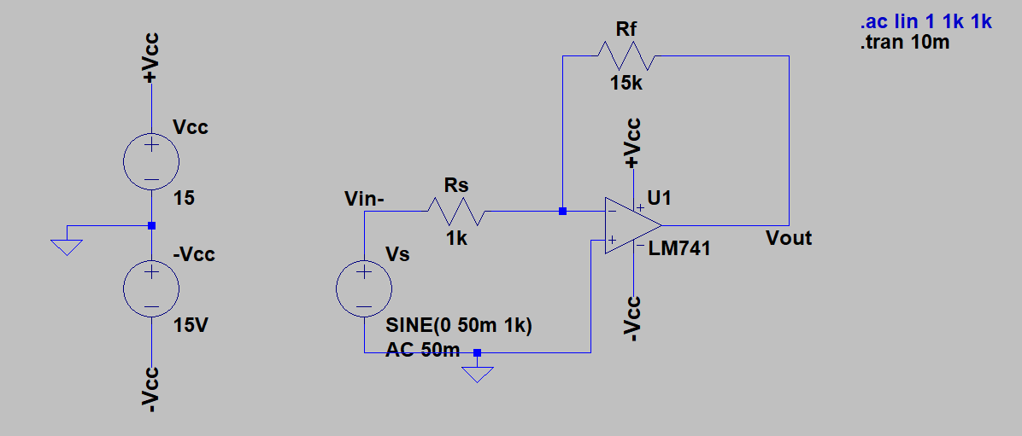

Fig 1.1 - Circuit diagram for Inverting Mode

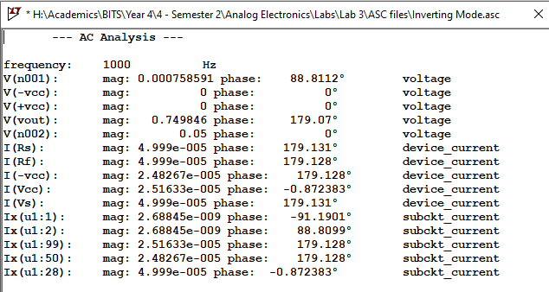

Fig 1.2 – AC Analysis for Inverting Mode

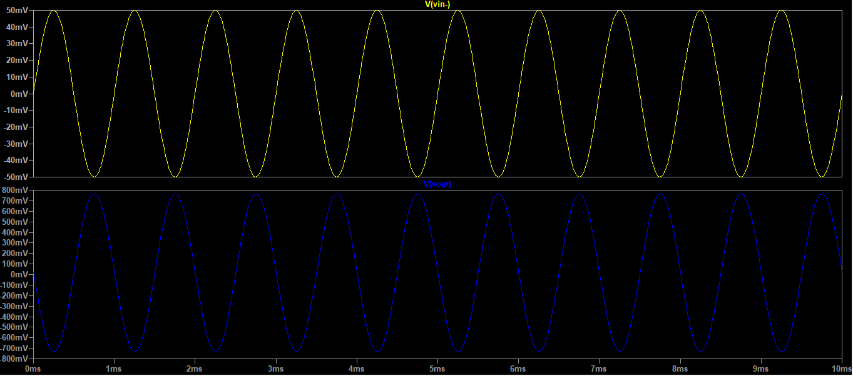

Fig 1.3- Input-Output waveform for Inverting Mode

Observations and Calculations

**From Theory:**

The output voltage for an inverting amplifier can be calculated using the formula

$${\text{A}}_{\text{v}}\text{ = }\frac{{\text{V}}_{\text{o}}}{{\text{V}}_{\text{s}}}\text{ =}-\frac{{\text{R}}_{\text{F}}}{{\text{R}}_{\text{s}}}$$

As **|Vs| = 50mV**, so

$$\text{|}{\text{V}}_{\text{0}}\text{| = }\frac{\text{15kΩ}}{\text{1kΩ}}\text{×50mV = 0.75V }$$

Negative sign of **Av** indicates phase shift by **180°**. Hence, if **Vs** has **0°** phase, the **Vo** must have **180°** phase.

Voltage gain (**Av**) = **-15**.

**Simulated:**

The amplitude of **Vo** comes out to be **0.749846V** with a phase of **179.07°**.

Voltage gain (**Av**) = -**14.99692**.

Conclusions

* The amplitude and phase of simulated waveform are very close to the expected results.
* The waveform is inverted and amplified.
* The simulated results are not exactly equal to theoretical results because the Op-Amp LM741 IC is not an ideal Op-Amp. It draws very small current (in order of nA) at its input, does not have infinite input resistance and zero output resistance, and has a finite gain which are the main causes of deviation from the expected theoretical results.

1. Non - Inverting Mode – Schematic, .ac results and Waveforms

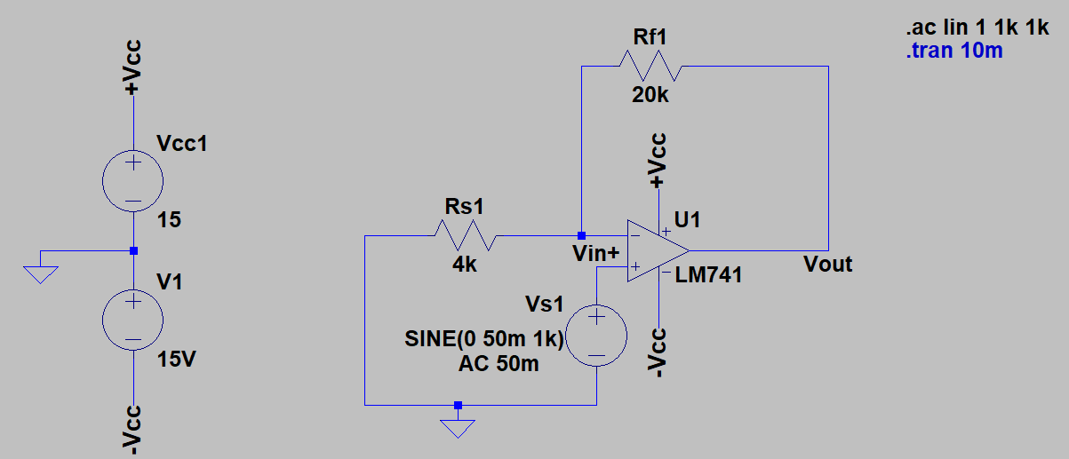

Fig 2.1- Circuit diagram for Non-Inverting Mode

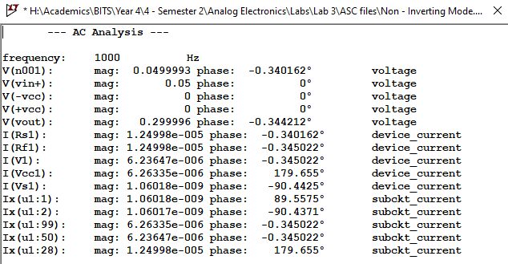

Fig 2.2 – AC Analysis for Inverting Mode

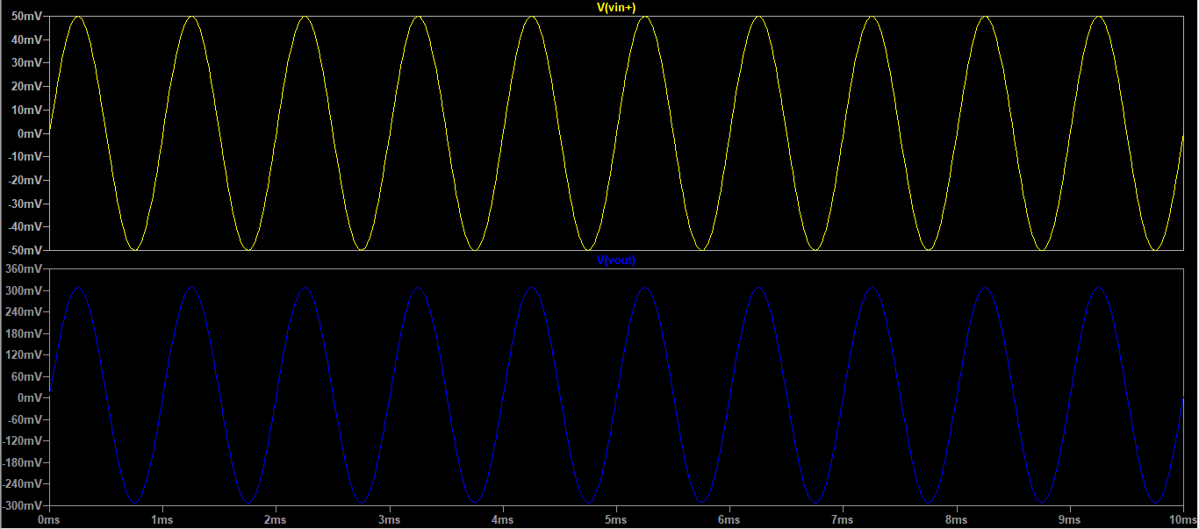

Fig 2.3 - Input-Output waveform for Non-Inverting Mode

Observations and Calculations

**From Theory:**

The output voltage for a non-inverting amplifier can be calculated using the formula

$${\text{A}}_{\text{v}}\text{ = }\frac{{\text{V}}_{\text{o}}}{{\text{V}}_{\text{s}}}\text{ = }1+\frac{{\text{R}}_{\text{F}}}{{\text{R}}_{\text{s}}}$$

As **|Vs| = 50mV**, so

$$\text{|}{\text{V}}_{\text{0}}\text{| =}\left(\text{ 1+}\frac{\text{20kΩ}}{\text{4kΩ}}\right)\text{×50mV = 0.3V }$$

Positive sign of **Av** indicates no phase shift. Hence, if **Vs** has **0°** phase, the **V0** must have **0°** phase.

Voltage gain (**Av**) = **6**.

**Simulated:**

The amplitude of **Vo** comes out to be **0.29996V** with a phase of -**0.34212°**.

Voltage gain (**Av**) = **5.99992**.

Conclusions

* The amplitude and phase of simulated waveform are very close to the expected results.
* The waveform is amplified and remains in phase.
* The simulated results are not exactly equal to theoretical results because the Op-Amp LM741 IC is not an ideal Op-Amp. It draws very small current (in order of nA) at its input, does not have infinite input resistance and zero output resistance, and has a finite gain which are the main causes of deviation from the expected theoretical results.

1. Adder – Schematic, .ac results and Waveforms

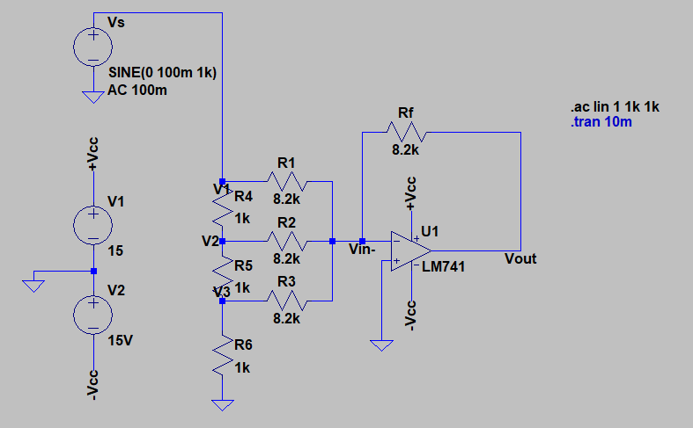

Fig 3.1 - Circuit diagram for Adder

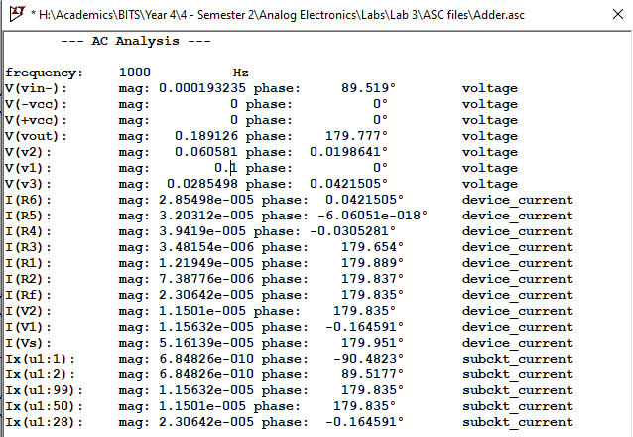Fig 3.2 - AC Analysis for Adder

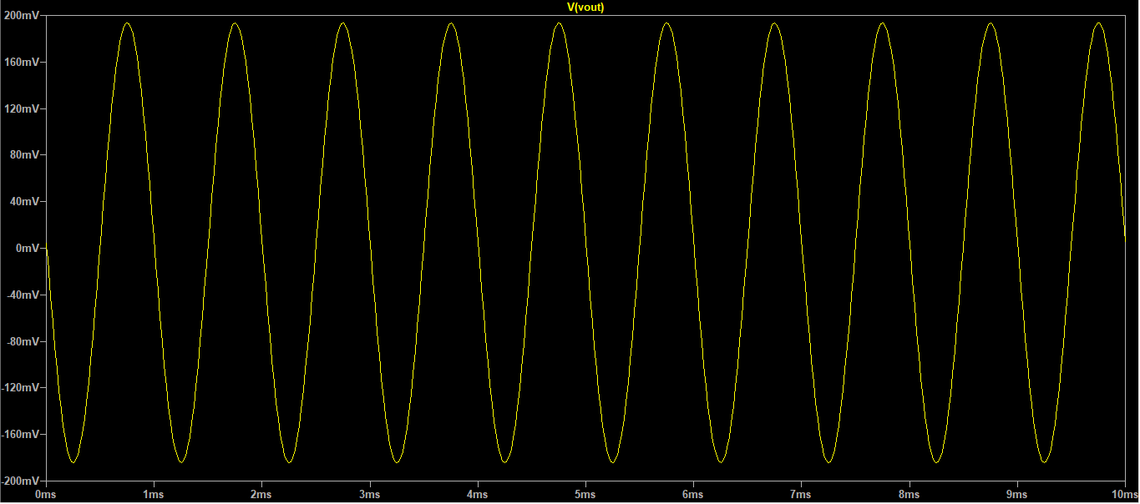

Fig 3.3 - Input-Output waveform for Adder

Observations and Calculations

**From Theory:**

The output voltage for a summing amplifier (adder) can be calculated using the formula

$${\text{V}}_{\text{o}}=-\left(\frac{{\text{R}}_{\text{F}}}{{\text{R}}_{\text{1}}}{\text{V}}_{\text{1}}\text{+}\frac{{\text{R}}_{\text{F}}}{{\text{R}}_{\text{2}}}{\text{V}}_{\text{2}}+\frac{{\text{R}}_{\text{F}}}{{\text{R}}_{\text{3}}}{\text{V}}_{\text{3}}\right)$$

As **|Vs| = 100 mV**, so from the values obtained we have

Vs = V1 = 100 mV

V2 = 60.581 mV

V3 = 28.5498 mV

hence

$$\left|{\text{V}}_{\text{o}}\right|=\left(\frac{\text{8.2 kΩ}}{\text{8.2 kΩ}}\text{×}\text{100 mV+}\frac{\text{8.2 kΩ}}{\text{8.2 kΩ}}\text{×60.581 mV}+\frac{\text{8.2 kΩ}}{\text{8.2 kΩ}}\text{×28.5498 mV}\right)=189.13\text{mV}$$

Negative sign of **Av** indicates phase shift of **180°**. Hence, if **Vs** has **0°** phase, the **Vo** must have **180°** phase.

**Simulated:**

The amplitude of **Vo** comes out to be **0.1892V** with a phase of **179.77°**.

Conclusions

* The amplitude and phase of simulated waveform are very close to the expected results.
* The waveform is inverted and has a higher magnitude than the input voltages.
* The simulated results are not exactly equal to theoretical results because the Op-Amp LM741 IC is not an ideal Op-Amp. It draws very small current (in order of nano Amperes) at its input, does not have infinite input resistance and zero output resistance, and has a finite gain which are the main causes of deviation from the expected theoretical results.
* If by error, we apply voltage division ignoring R1, R2 and R3, then the theoretical results are very different from the results from simulation. Hence, we should use values of V1, V2 and V3 from the analysis itself for theoretical calculations.

1. Subtractor – Schematic, .ac results and Waveforms

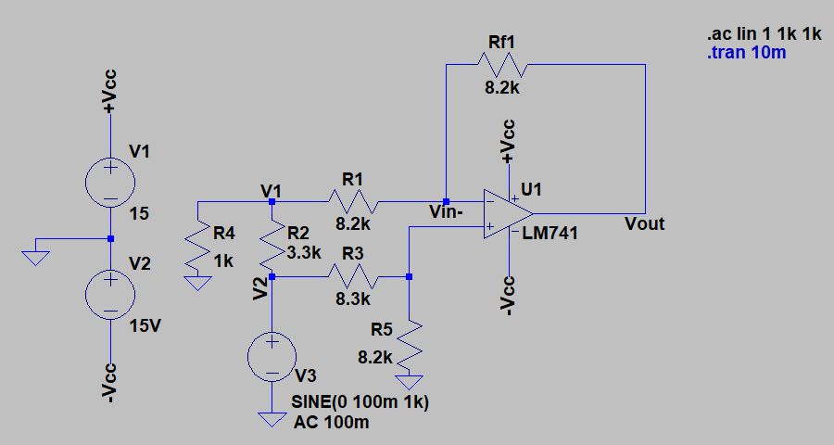

Fig 4.1 - Circuit diagram for Subtractor

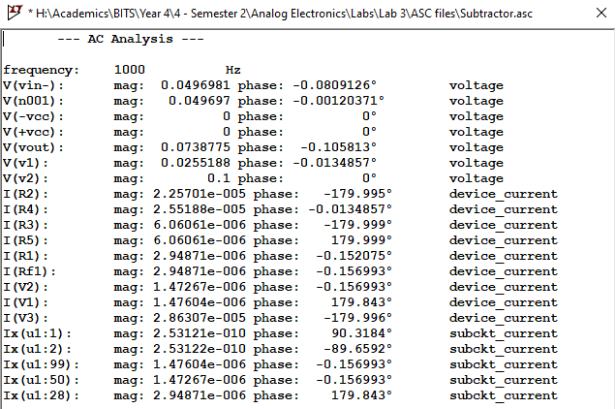

Fig 4.2 - Analysis for Subtractor

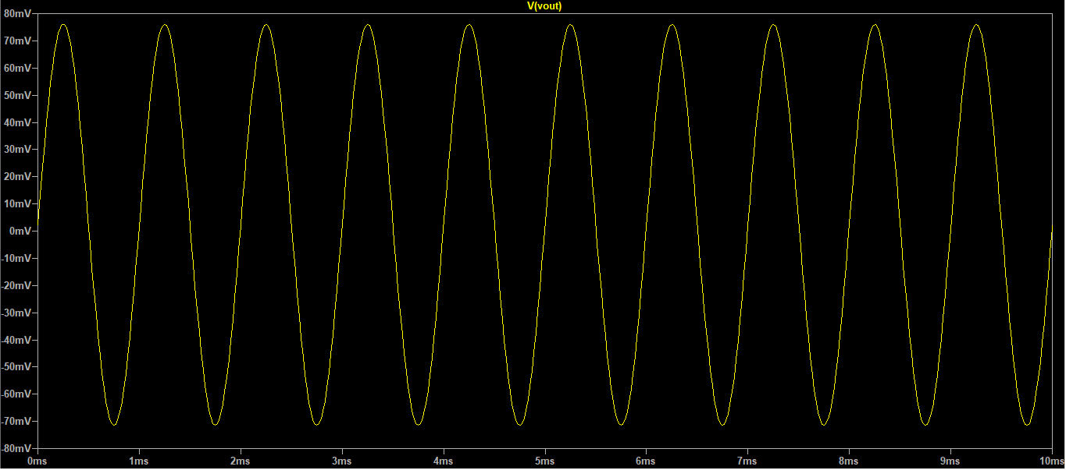

Fig 4.3 - Input-Output waveform for Subtractor

Observations and Calculations

**From Theory:**

The output voltage for a difference amplifier (subtractor) can be calculated using the formula

$${\text{V}}_{\text{o}}=\frac{{\text{R}}_{\text{F}}}{{\text{R}}_{\text{1}}}{\text{(V}}_{\text{1}}-{\text{V}}_{\text{2}})$$

As **|Vs| = 100 mV**, so from the values obtained we have

V1 = 25.5118 mV

Vs = V2 = 100 mV

Positive sign of **Av** indicates no phase shift. Hence, if **Vs** has **0°** phase, the **Vo** must have **0°** phase.

**Simulated:**

The amplitude of **Vo** comes out to be **0.0738775 V** with a phase of **-0.1058°**.

Conclusions

* The amplitude and phase of simulated waveform is very close to the expected results.
* The waveform is amplified with respect to difference of the voltages V1 and V2 and remains in phase.
* The simulated results are not exactly equal to theoretical results because the Op-Amp LM741 IC is not an ideal Op-Amp. It draws very small current (in order of nano Amperes) at its input, does not have infinite input resistance and zero output resistance, and has a finite gain which are the main causes of deviation from the expected theoretical results.
* If by error, we apply voltage division ignoring R1 and R2, then the theoretical results are very different from the results from simulation. Hence, we should use values of V1 and V2 from the analysis itself for theoretical calculations.

Results

|  |  |  |  |
| --- | --- | --- | --- |
| **S.No** | **Configuration** | **Simulated Value** | **Theoretical Value** |
| 1 | Inverting mode | Av = -14.99692 | Av = -15 |
| 2 | Non-Inverting mode | Av = 5.9992 | Av = 6 |
| 3 | Adder | Vout = 0.189126 V | Vout = 0.18913 V |
| 4 | Subtractor | Vout = 0.0738775 V | Vout = 0.0744882 V |

**__________________________________________________________________________________________**